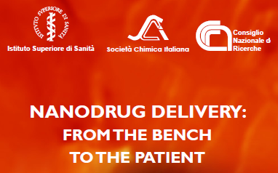

10-13 October 2011
Aula Pocchiari
Istituto Superiore di Sanità
Viale Regina Elena, 299 - Rome, ITALY

APPLICATION FORM
First Name ________________ Surname _______________________________
Date and place of birth ______________________________________________
University/company _______________________ Department _______________
Address _______________________________________________________
City _________________ ZIP code ________ Telephone ________________
FAX _________________ e-mail ____________________________________

Fees paid (please select):
Students and temporary personnel:
□ 150 euro early registration; □ 170 euro late registration
All the others: □ 300 euro early registration; □ 350 euro late registration

to be sent to nanodrug.delivery@cnr.it within 30 August, 2011
please, attach a copy of your proof of payment

